Title of the Abstract

Presenting Author¹, Other Author^{1, 2}, Other Author¹

¹Department Name, Institution Address
²Department Name, Institution Address
* emailid@email.com

Abstract a maximum of 300 words in Times New Roman font, with size as 11 points, Justified with a line spacing of 1.15 and a paragraph spacing of 12 points after each paragraph.
The Title of the Abstract should be in Times New Roman Font, Bold and 14 points in size and the Author Names should be in Times New Roman font, 12 points in size. The Affiliation to be in Times New Roman font, 11 points in size, Italics and the email id in Times New Roman font, 10 points in size with one line gap after the Title of the Abstract, Author Names and email id and single line spacing in between as shown above.
Please note that the Abstract should be limited to a one-page article and only key references can be mentioned in the format as given below.
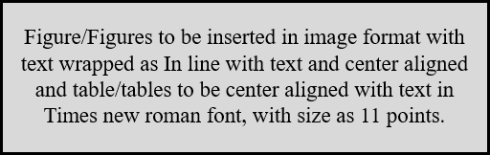
Figure 1/ Table 1: Figure/Table to be inserted as caption with Times New Roman font, size as 10 points and center aligned with single line spacing.

[1] First Author, Second Author,... Title of the work published. Title of the Journal, Volume, page (Year).

*Note: If there are any queries please send email to
icqms2025@gmail.com

